CO₂ Traffic Light for Monitoring Indoor Air Quality
The CO2 Guard 10 reliably measures the CO₂ concentration indoors. The measuring device uses an LED traffic light system to indicate when it is time to ventilate.

(Engerwitzdorf, 23.10.2020) The CO2 Guard 10 by E+E Elektronik precisely measures the CO₂ concentration of the indoor air. The battery-operated CO₂ traffic light is perfect for use in indoor environments such as classrooms, offices or meeting rooms. An easy-to-understand LED traffic light system with an acoustic threshold value indicator delivers information on the air quality. The CO₂ measuring device serves as a reference value encoder for demand-oriented and energy-efficient room ventilation.

Ventilation in Times of Corona
Ventilation of indoor spaces has gained enormously in importance due to the Corona pandemic. Based on current knowledge, the Corona virus (COVID-19) can spread via aerosols in enclosed spaces. To reduce the risk of infection, it is recommended that rooms be ventilated regularly. This is because the higher the proportion of fresh air is, the lower the aerosol concentration is in the indoor air. This also reduces the risk of infection through potentially viral particles.

CO₂ Concentration as an Indicator
The CO₂ concentration is a reliable indicator for the indoor air quality. In rooms with a high density of people, the CO₂ concentration rises rapidly. In addition to an increased risk of infection, a high CO₂ level leads to fatigue, lack of concentration, discomfort and headaches. Especially in schools, but also in offices or meeting rooms, it is therefore important to ventilate regularly and adequately. CO₂ traffic lights help to ensure that the room is ventilated in line with requirements and in an energy-efficient manner.

CO₂ Traffic Light for Demand-Driven Ventilation
The CO2 Guard 10 by E+E Elektronik is a battery-powered CO₂ traffic light for use in schools, public buildings and commercial premises. The device measures the CO₂ concentration and displays the measured values in an easy-to-understand manner using a six-part LED traffic light. In addition, an acoustic warning signal is emitted as soon as the next higher threshold value is reached. The CO2 Guard 10 therefore provides a reliable basis for an individual, demand-driven ventilation strategy.

As ventilation by opening windows incurs heat loss, especially in the winter, occupants should only ventilate for as long as needed. The CO2 Guard 10 indicates when the CO₂ concentration has returned to the desired level and the windows can be closed. This helps to keep heat losses low and save energy costs.

Easy Handling, State-of-the-Art Measuring Technology
The CO2 Guard 10 is immediately ready for use. Only four standard AAA batteries are required for operation. As no external power supply is required, the CO₂ traffic light can be placed at any suitable location in the room. Besides use as a desktop unit, the device can also be wall-mounted.

The key component in the CO2 Guard 10 is the high-quality EE895 CO₂ sensing module by E+E Elektronik. It is based on the dual wavelength NDIR measurement principle, which offers long-term stability and ensures precise and reliable CO₂ measurement values. Thanks to smart auto-calibration, the sensor is practically maintenance-free. In addition, temperature and pressure compensation ensures high CO₂ measuring accuracy, regardless of the location (sea level) and ambient conditions.

Quality from Austria
E+E Elektronik exclusively produces both the CO₂ traffic light and the EE895 sensing module, along with its sensors and measuring devices, at its Austrian headquarters in Engerwitzdorf. The company draws on many years of experience and expertise in CO₂ measuring technology. In addition to CO₂ measuring devices, E+E Elektronik also offers sensors and measuring instruments for humidity, dew point, moisture in oil, air velocity, flow, temperature and pressure. These highly accurate devices are used worldwide in a wide range of industrial and building automation applications.

Characters (incl. spaces): 4054
Words: 624

Images:
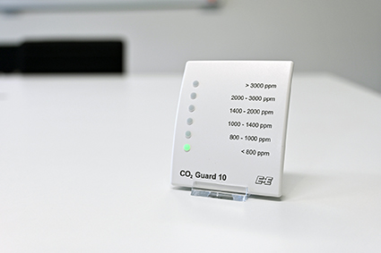
Using a six-part LED traffic light, the CO2 Guard 10 provides information about the current CO₂ content of the indoor air.

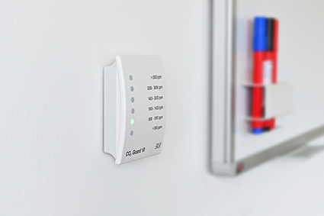
The CO2 Guard 10 can also be wall-mounted.

Photos: E+E Elektronik GmbH, reprint free of charge

Company Profile
E+E Elektronik develops and manufactures sensors and transmitters for humidity, dew point, moisture in oil, CO₂, air velocity, flow, temperature and pressure. Hand-held meters, humidity calibration systems and calibration services complete the comprehensive product portfolio of the Austrian sensor specialist. The main applications for E+E products lie in HVAC, building automation, industrial process control and the automotive industry. A certified quality management system according to ISO 9001 and IATF 16949 ensures the highest quality standards. E+E Elektronik is represented with own subsidiaries in China, Germany, France, Italy, Korea, USA and sales partners in more than 60 countries worldwide. The accredited E+E calibration laboratory has been commissioned by the Austrian Federal Office for Metrology (BEV) to provide the national standards for humidity, dew point and air velocity.

E+E Elektronik Ges.m.b.H.
Langwiesen 7
4209 Engerwitzdorf
Austria
T: +43 (0) 7235 605-0
F: +43 (0) 7235 605-8
info@epluse.at
www.epluse.com

Press contact:
Mr. Johannes Fraundorfer
T: +43 (0)7235 605-217
pr@epluse.at

